Question 2: Find the locations, where these email servers are hosted.

First find out mail servers of host

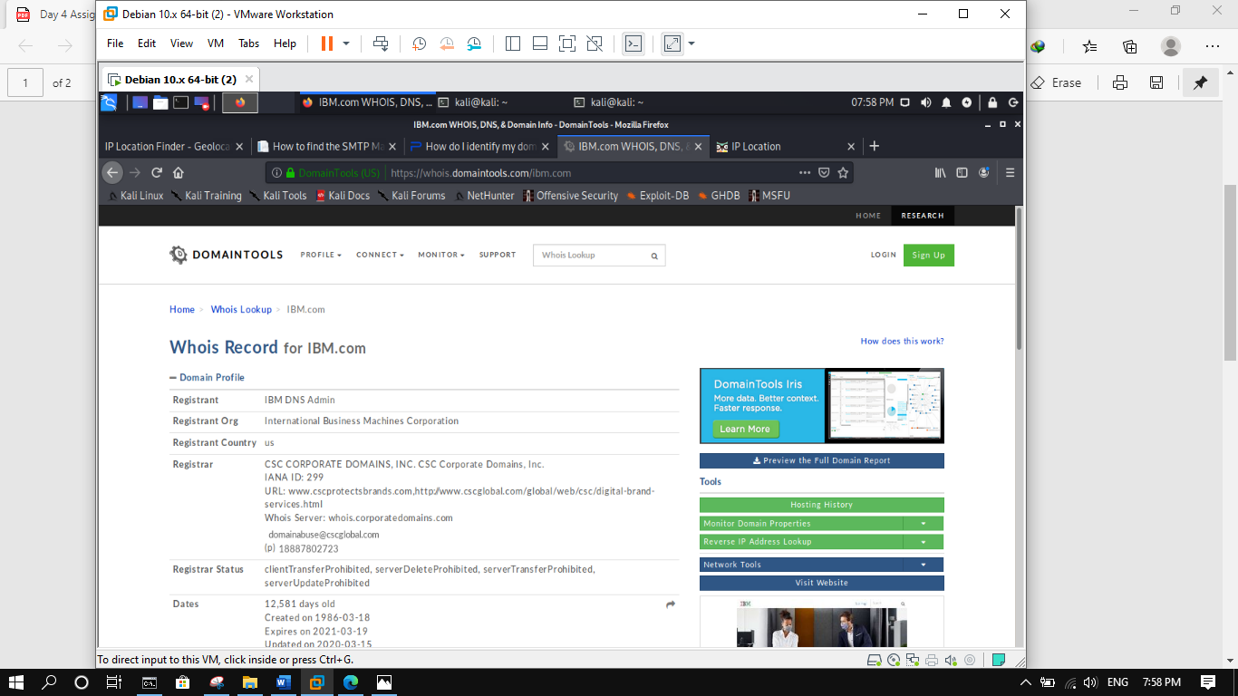

Then serac IP address in iplocation.com

